SQL QUERIES AS400 Mohammad Imran
UID:307353
Tenu22
ASSIGNMENT

Creating Table:

CREATE TABLE Persons22 (
PersonID int,
LastName varchar(20),
FirstName varchar(20),
Address varchar(20),
City varchar(20)
)

Note:Here the table persons22 table is created

Insert INTO:

INSERT INTO PERSONS22 (PersonID, LastName, FirstName,Address, City,)
VALUES ('6', 'Mohammad', 'Imran', 'Telangana', 'Hyderabad')
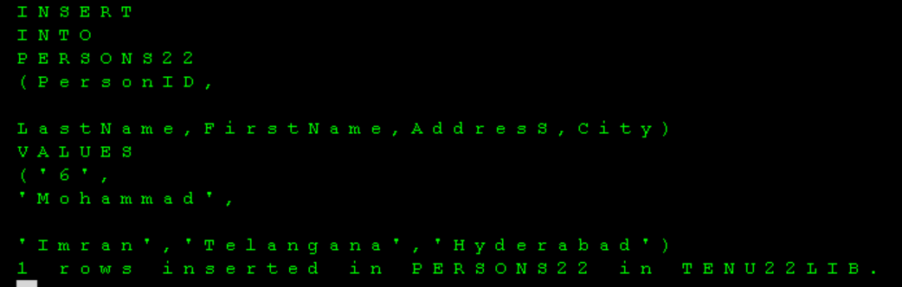
Note:Insert the values into the table

Update:
UPDATE Persons22
SET Address = 'Telangana'
WHERE PersonID = 23


**Note:**Updating the value in the table using PersonID
select ,min:


Max:


SELECT DISTINCT:
SELECT DISTINCT *
FROM PERSONS22


ORDER BY :

SELF JOIN:
SQL ALL:

COUNT:


BETWEEN:


ALIASES:
DELETE:

ALTER:
DROP TABLE:

